Paddle with the Friends of the Vernon Marsh and the
Schussboomers Ski and Snowboard Club
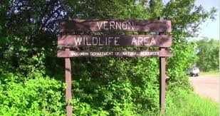
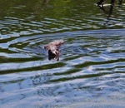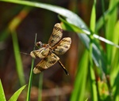
Saturday, June 13, 2015
9:30 AM to 12:30 PM
Rain or shine (excluding thunderstorms or downpours).
Meeting Place and route to be determined based on weather and water levels.
BYO canoe or kayak, or use one of the DNR’s complimentary canoes (paddles and life vests included).
RSVP to Allen Stasiewski at astasiewsk@aol.com or by phone at
414-507-8358
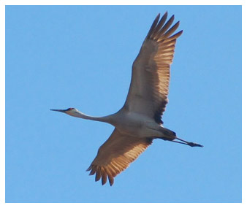
Friends of Vernon Marsh, formed in 2008, works to restore native plant and wildlife communities and enhance the quality of the outdoor experiences enjoyed by visitors to Vernon Marsh. Equally important, Friends of Vernon Marsh helps educate the public on the important role that Vernon Marsh plays in the protection, cleansing and recharge of water resources, and the preservation of wildlife and open spaces.

