Kayak Mirror Lake
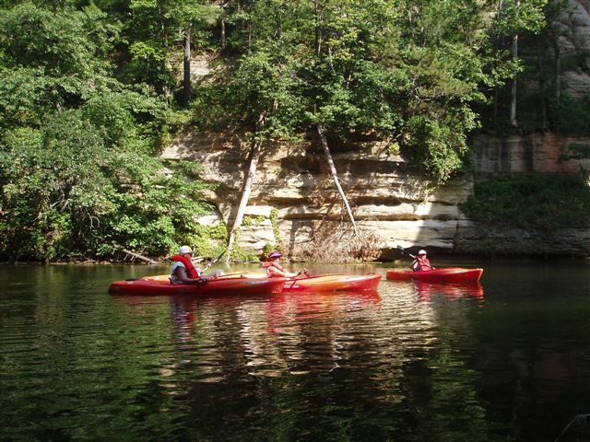
Kayak Mirror Lake Saturday, August 22, 2015
9:00 AM – 7:00 PM
$40 Single All day Rental Fee 9 AM-7 PM payable the day of the event $50 double or sit-on-top kayak includes life jacket and paddle(s). Sales tax of 5.5% will be added.

We’ll take a paddle break to enjoy a picnic lunch at the boat launch and then back on to the water to investigate another area of Mirror Lake.

If you would like to extend your experience of Mirror Lake, beautiful camp sites can be reserved (608)254-2333 or on line www.mirrorlakewisconsin.com

If camping is not your bag, consider lodging with several of us Friday, August 21st and Saturday, August 22nd in Tambourine Pines at Christmas Mountain Resort. The total cost for two nights lodging (based on 6 people, maximum capacity 8) is approx. $76 per person including tax. Ask Kathlene Sisson, Joann Jacobs and Darlene Kelly to share their experiences of lodging in the Dells after our paddle last season.

From Interstate 90-94 Mirror Lake State Park is conveniently located near Interstate Highway 90-94. Exit I-90-94 to U.S. Highway 12 south of Wisconsin Dells.

RSVP’S: LODGING BY MAY 15TH Darlene Kelly 262-367-8377 dardankelly@aol.com

BOAT RENTAL BY AUG. 1st Jan Vogt 414-218-6673 E-mail jmoosecat@wi.rr.com

